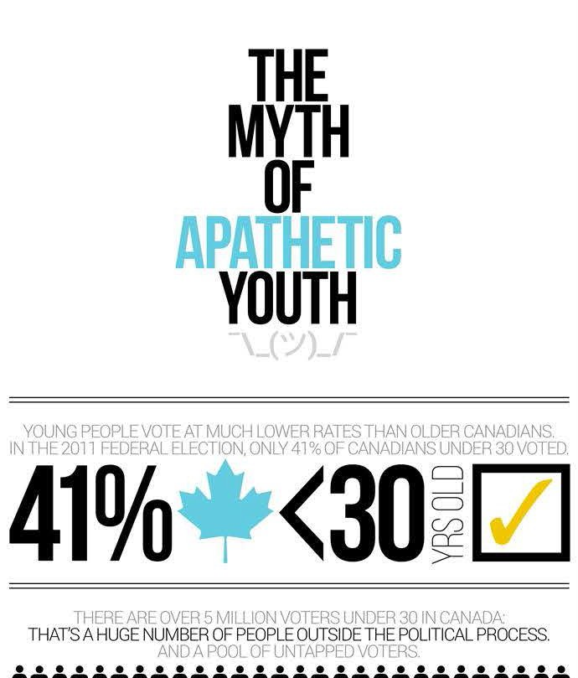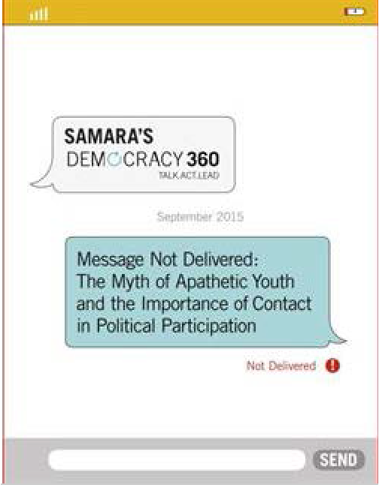
Research Educate Book EPCitizen Blog About Engage Election
Français
Youth Are Not Apathetic

 | Youth Are Not Apathetic |  | Search:
 |  |  | Subscribe to our newsletter
 | Over the last 30 years, Canadians have watched with concern as voting rates among younger people have declined, with the result that in the 2011 federal election, the majority of young people opted not to cast a vote. The low voting rate among younger Canadians is often viewed as evidence that young people today are more apathetic or lazy than any other generation before. Samara's latest research “Message Not Delivered” debunks these myths. Check out this infographic of the main findings.
 |  |  | Donate to this Charity
 |  |  | Join us on Follow us on
 |  |  | Read the full report
Subscribe |  | Donate |  | Share

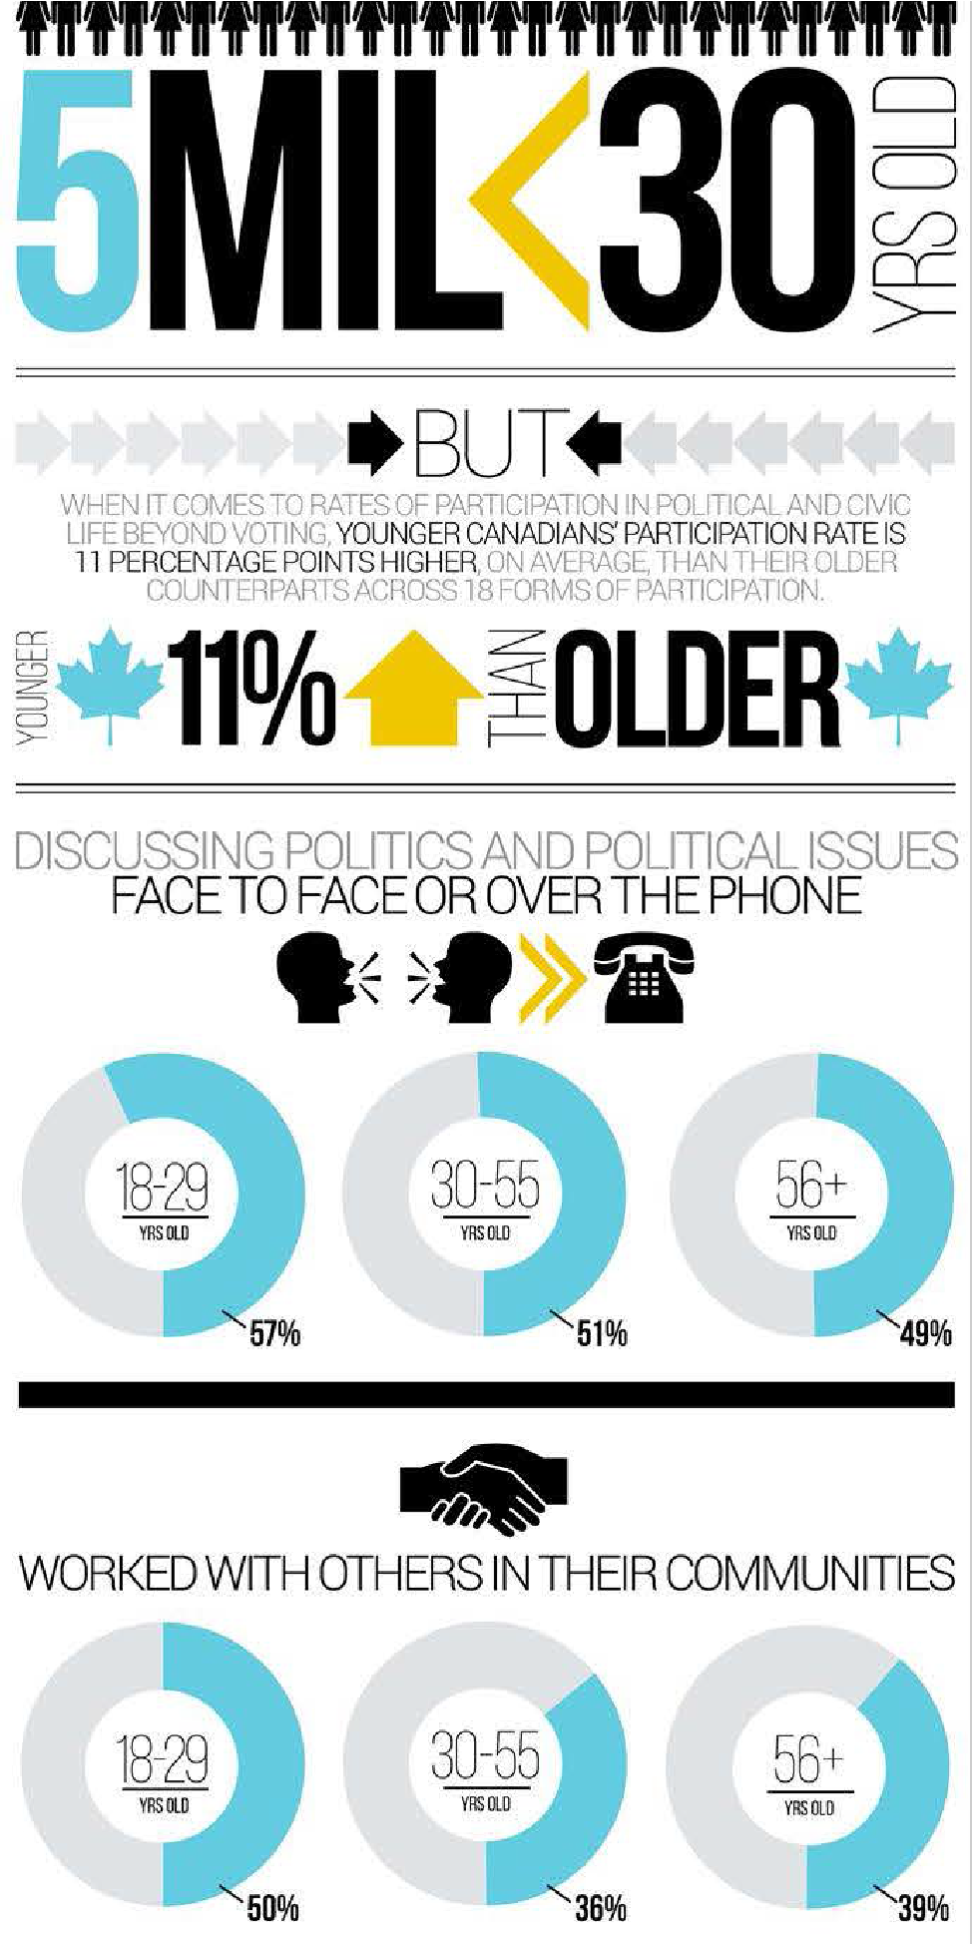

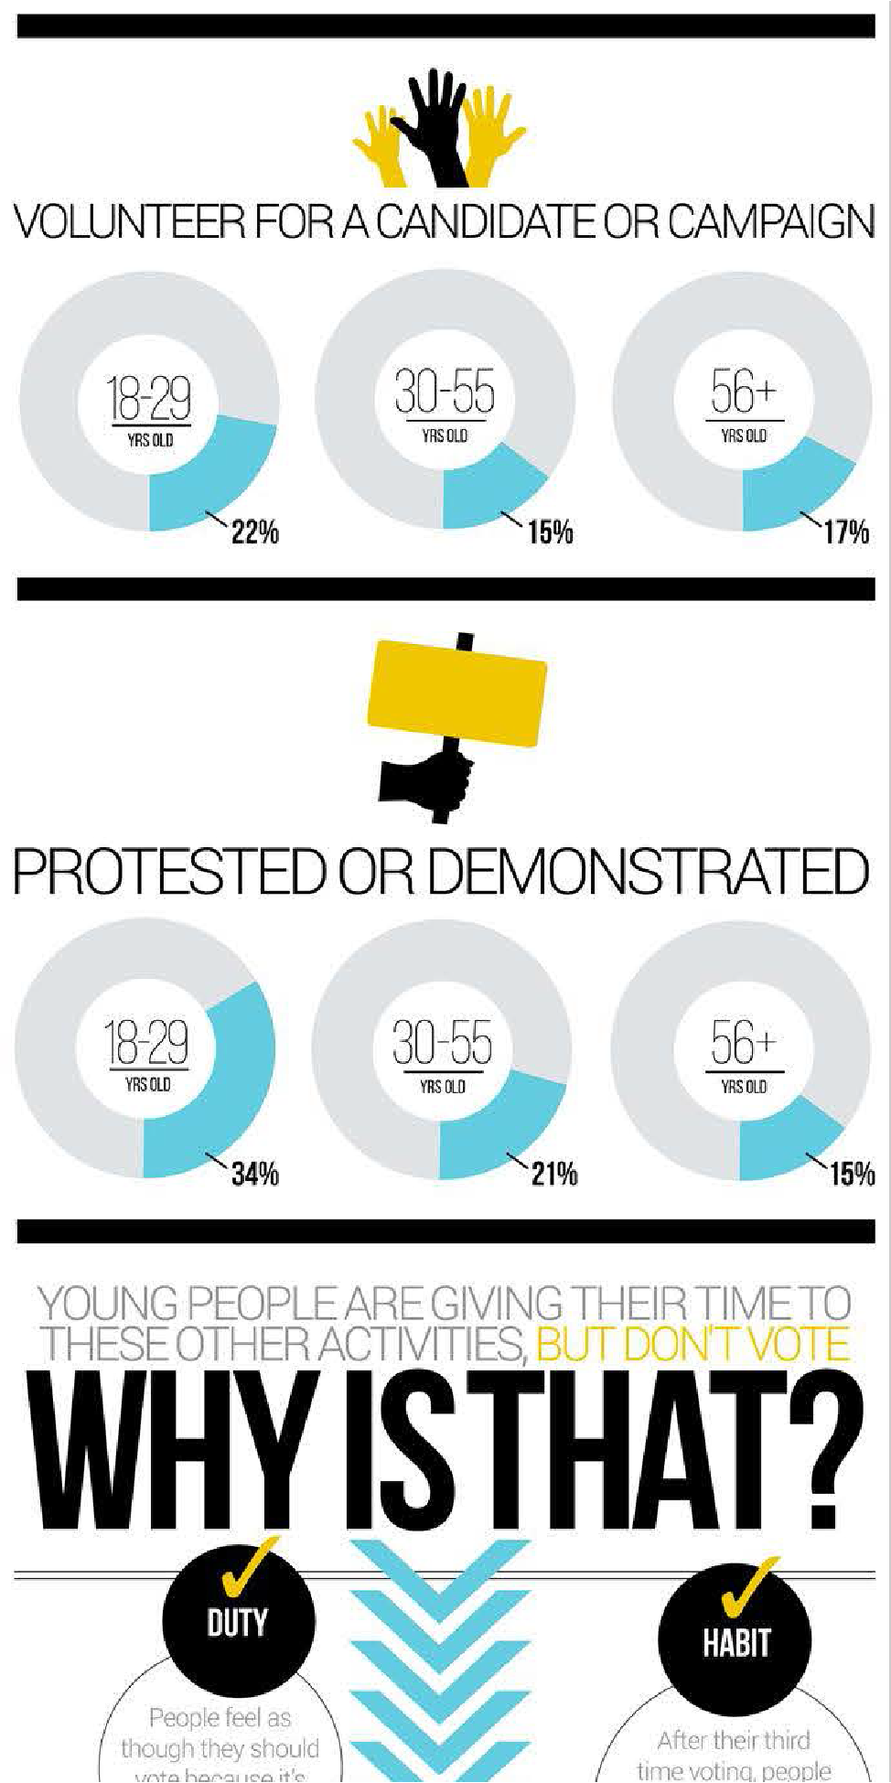

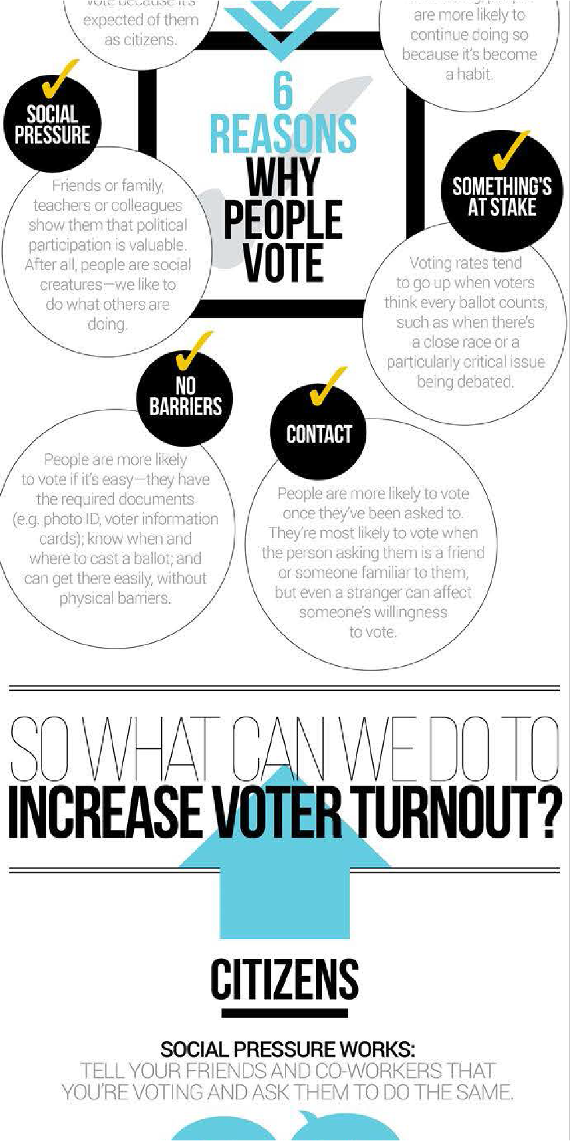

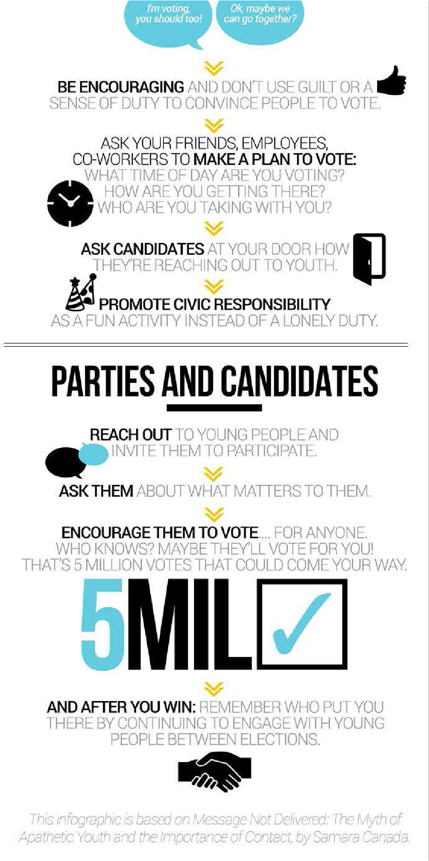

© Copyright 2015 Samara. All rights reserved.
Terms of Use Privacy Policy

